# Modulation

# *What is Modulation?*

For a signal to be transmitted to a distance, without the effect of any external interferences or noise addition and without getting faded away, it has to undergo a process called as **Modulation**. It improves the strength of the signal without disturbing the parameters of the original signal.

## **What is Modulation?**

A message carrying a signal has to get transmitted over a distance and for it to establish a reliable communication, it needs to take the help of a high frequency signal which should not affect the original characteristics of the message signal.

The characteristics of the message signal, if changed, the message contained in it also alters. Hence, it is a must to take care of the message signal. A high frequency signal can travel up to a longer distance, without getting affected by external disturbances. We take the help of such high frequency signal which is called as a **carrier signal** to transmit our message signal. Such a process is simply called as Modulation.

Modulation is the process of changing the parameters of the carrier signal, in accordance with the instantaneous values of the modulating signal.

### **Need for Modulation**

Baseband signals are incompatible for direct transmission. For such a signal, to travel longer distances, its strength has to be increased by modulating with a high frequency carrier wave, which doesn’t affect the parameters of the modulating signal.

## **Advantages of Modulation**

The antenna used for transmission, had to be very large, if modulation was not introduced. The range of communication gets limited as the wave cannot travel a distance without getting distorted.

Following are some of the advantages for implementing modulation in the communication systems.

* Reduction of antenna size
* No signal mixing
* Increased communication range
* Multiplexing of signals
* Possibility of bandwidth adjustments
* Improved reception quality

## **Signals in the Modulation Process**

Following are the three types of signals in the modulation process.

### **Message or Modulating Signal**

The signal which contains a message to be transmitted, is called as a **message signal**. It is a baseband signal, which has to undergo the process of modulation, to get transmitted. Hence, it is also called as the **modulating signal**.

### **Carrier Signal**

The high frequency signal, which has a certain amplitude, frequency and phase but contains no information is called as a **carrier signal**. It is an empty signal and is used to carry the signal to the receiver after modulation.

### **Modulated Signal**

The resultant signal after the process of modulation is called as a **modulated signal**. This signal is a combination of modulating signal and carrier signal.

## **Types of Modulation**

There are many types of modulations. Depending upon the modulation techniques used, they are classified as shown in the following figure.

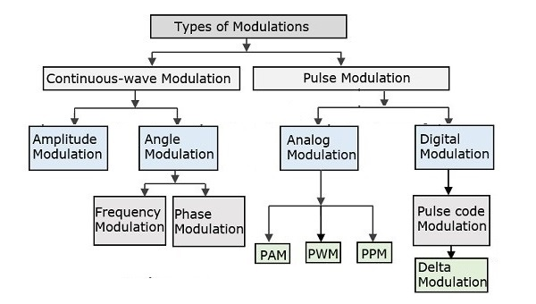

The types of modulations are broadly classified into continuous-wave modulation and pulse modulation.

### **Continuous-wave Modulation**

In continuous-wave modulation, a high frequency sine wave is used as a carrier wave. This is further divided into amplitude and angle modulation.

* If the amplitude of the high frequency carrier wave is varied in accordance with the instantaneous amplitude of the modulating signal, then such a technique is called as **Amplitude Modulation**.
* If the angle of the carrier wave is varied, in accordance with the instantaneous value of the modulating signal, then such a technique is called as **Angle Modulation**. Angle modulation is further divided into frequency modulation and phase modulation.
  + If the frequency of the carrier wave is varied, in accordance with the instantaneous value of the modulating signal, then such a technique is called as **Frequency Modulation**.
  + If the phase of the high frequency carrier wave is varied in accordance with the instantaneous value of the modulating signal, then such a technique is called as **Phase Modulation**.

### **Pulse Modulation**

In Pulse modulation, a periodic sequence of rectangular pulses, is used as a carrier wave. This is further divided into analog and digital modulation.

In analog modulation technique, if the amplitude or duration or position of a pulse is varied in accordance with the instantaneous values of the baseband modulating signal, then such a technique is called as Pulse Amplitude Modulation (PAM) or Pulse Duration/Width Modulation (PDM/PWM), or Pulse Position Modulation (PPM).

In digital modulation, the modulation technique used is Pulse Code Modulation (PCM) where the analog signal is converted into digital form of 1s and 0s. As the resultant is a coded pulse train, this is called as PCM. This is further developed as Delta Modulation (DM). These digital modulation techniques are discussed in our Digital Communications topic

# *Different Types of Modulation Techniques*

Communication is the basic attraction of mankind as it gives the knowledge of what is going on around us. In our daily life, we communicate with many people and use the entertainment media like television, radio, internet and newspaper to get ourselves involved. These entertainment media act as a source of communication. [Electronic communication](https://www.watelectronics.com/different-types-of-wireless-communication-technologies/) comprises TV, radio, internet, etc. When we want to transmit a signal from one location to another, we have to strengthen the signal. After undergoing strenghthening process the signal travels to a long distance. This is called as modulation, and this article gives an overview of the modulation and types of modulation techniques.

Communication is nothing but, the process of exchanging (two way communication) or passing (one way communication) information from one person to another. The basic electronic communication system consists of these components: transmitter, receiver and communication channel.

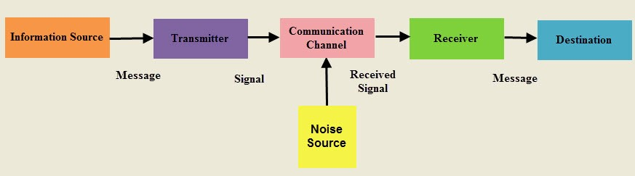

**Communication System**

A **transmitter** is a group of electronic circuits designed to convert the information into a signal for transmission over a given communication medium.

A **receiver** is a group of electronic circuits designed to convert the signal back to the original information.

The communication channel is the medium which is designed to transmit the electronic signal from one place to another.

## **What is Modulation?**

Modulation is nothing but, a carrier signal that varies in accordance with the message signal. Modulation technique is used to change the signal characteristics. Basically, the modulation is of following two types:

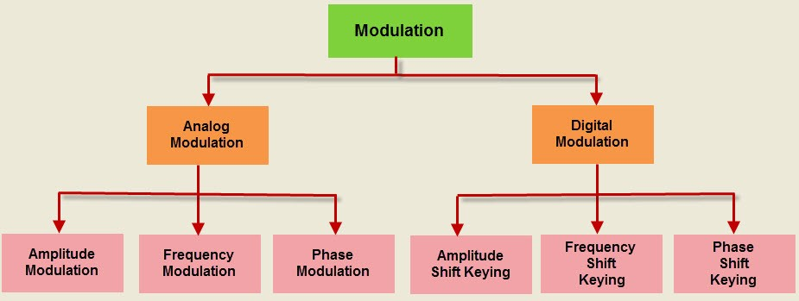

**Modulation Techniques**

* Analog Modulation
* Digital Modulation

**What is Analog Modulation: Types & Its Applications**

Conveying of our messages to someone happens through voice, few gestures, expressions. This is the human way of communication. Whereas in the technological context, there are multiple ways of transmitting messages either in the form of audio, digital bits and baseband signal transmissions. The fundamental method of transmission is telecommunication and modulation is the core system for any of the telecommunication devices. These days, the standard forms of communication devices are co-axial cables, microwaves, copper wires, and even [wireless](https://www.watelectronics.com/different-types-of-wireless-communication-technologies/) communication. The transmission happens either in the form of analog or digital and these signals have to be modulated to remove noise effects, to travel over long distances and remove attenuation effects. And the one kind of modulation we are going to discuss today is “Analog Modulation”.

## **What is Analog Modulation?**

An analog signal is a continuous wave where the time differing variable of the wave is represented in the relation of other time differing quality which is analogous to other time changing signals. And analog modulation is the procedure of transmitting low-frequency signals such as TV signals or audio signals with that of high-frequency carrier signals like that of radio frequency signals. In this type of [modulation](https://www.watelectronics.com/types-of-modulation-techniques-with-applications/), a bandpass channel is required where it corresponds to the specified range of frequencies. These frequencies are transmitted over a bandpass filter which allows certain frequencies to pass preventing signals at undesirable frequencies.

OR

### **Analog Modulation**

In analog modulation, analog signal (sinusoidal signal) is used as a carrier signal that modulates the message signal or data signal. The general function Sinusoidal wave’s is shown in the figure below, in which, three parameters can be altered to get modulation – they are amplitude, frequency and phase; so, the types of analog modulation are:

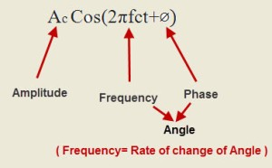

#### **Amplitude Modulation**

Amplitude modulation was developed in the beginning of the 20th century. It was the earliest modulation technique used to transmit voice by radio. This type of modulation technique is used in electronic communication. In this modulation, the amplitude of the carrier signal varies in accordance with the message signal, and other factors like phase and frequency remain constant.

The modulated signal is shown in the below figure, and its spectrum consists of the lower frequency band, upper frequency band and carrier frequency components. This type of modulation requires more power and greater bandwidth; filtering is very difficult. Amplitude modulation is used in computer modems, VHF aircraft radio, and in portable two-way radio

#### **Frequency Modulation**

In this type of modulation, the frequency of the carrier signal varies in accordance with the message signal, and other parameters like amplitude and phase remain constant. Frequency modulation is used in different applications like radar, radio and telemetry, seismic prospecting and monitoring newborns for seizures via EEG, etc.

This type of modulation is commonly used for broadcasting music and speech, magnetic tape recording systems, two way radio systems and video transmission systems. When noise occurs naturally in radio systems, frequency modulation with sufficient bandwidth provides an advantage in cancelling the noise.

#### **Phase Modulation**

In this type of modulation, the phase of the carrier signal varies in accordance with the message signal. When the phase of the signal is changed, then it affects the frequency. So, for this reason, this modulation is also comes under the frequency modulation.

Generally, phase modulation is used for transmitting waves. It is an essential part of many digital transmission coding schemes that underlie a wide range of technologies like GSM, WiFi, and satellite television. This type of modulation is used for signal generation in al synthesizers, such as the Yamaha DX7 to implement FM synthesis.

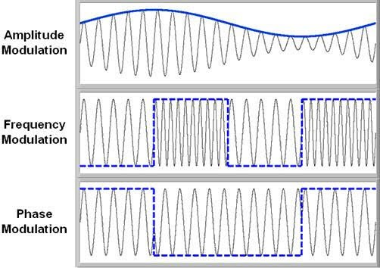

**Types of Analog Modulation**

Therefore, Analog modulation includes AM, FM and PM and these are more sensitive to noise. If noise enters into a system, it persists and gets carried up to the end receiver. So, this drawback can be overcome by the digital modulation technique.

## **Types of AM**

The type of analog modulation is based on the type of carrier signal property and so there are mainly three kinds of analog modulations and are

* Amplitude Modulation
* Frequency Modulation
* [Phase Modulation](https://www.watelectronics.com/what-is-phase-modulation-its-derivatives-waveforms/)

### **Amplitude Modulation**

In amplitude [modulation](https://www.watelectronics.com/sine-pulse-width-modulation-spwm-working/), the amplitude of the carrier signal is varied in correspondence with the amplitude of the modulating signal by maintaining frequency and phase at constant. Here, is the pictorial representation of amplitude modulation.

***Modulation.***

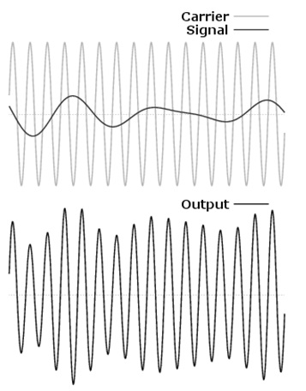

When the modulating (input signal) is represented as

**i(t) = Aicos(2∏fit)**

and the carrier signal is represented as

**c(t) = Accos(2∏fct)**

And in the expressions, Ai and Ac represent the amplitudes of two waves while fi and fc are the frequencies of the two waves correspondingly.

Solving the two expressions, a modulated wave is represented as

**M(t) = [Ai + Ac cos (2∏ (fi + fc)t )]**

The modulating signal has a bandwidth which is twice the bandwidth of the message signal i.e. 2fi

### **Frequency Modulation**

In frequency modulation, the frequency of the carrier signal is varied in correspondence with the amplitude of the modulating signal by maintaining amplitude and phase at constant. Here, is the pictorial representation of frequency modulation.

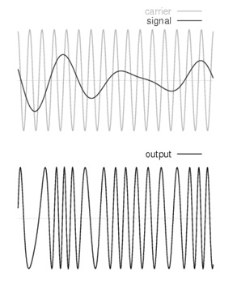

When the modulating (input signal) is represented as i(t)

and the carrier signal is represented as

**c(t) = Accos(2∏fct)**

then the frequency-modulated wave is

**M(t) = A cos (2∏fc + ks(t)t + Ф)**

The bandwidth of the FM modulated wave has to be considered in two cases

1. In narrowband FM, the bandwidth is two times the maximum frequency of the FM.
2. In wideband FM, the bandwidth is very large of the FM spectrum.

#### **Phase Modulation**

In phase modulation, the phase of the carrier signal is varied in correspondence with the amplitude of the modulating signal by maintaining amplitude and frequency at constant. Here, is the pictorial representation of phase modulation.

P(t) = Accos[Wct + kpm(t)]

Here Ac represents the amplitude of the carrier signal

Wc represents the carrier signal’s angular frequency = 2∏fc

And m(t) represents the modulating signal

The bandwidth of the PM modulated wave has to be considered in two cases

1. For minimum amplitude signals, the bandwidth is
2. In wideband FM, the bandwidth is very large in the FM spectrum.

### **Differences between Analog and Digital Modulation Techniques**

Both analog and digital modulation techniques are mostly implemented and the main difference that lies between these is the type of data they used to transmit the message. In analog modulation, the inputs have to be analog format and in digital modulation, the input has to be in digital format. Based on the type of applied input, the output is also quite separate.

|  |  |
| --- | --- |
| **Analog Modulation** | **Digital Modulation** |
| Any values that lie in between the minimum and maximum ranges of the transmitted signal are considered as valid. | In digital modulation, only two values are considered and are “1” (HIGH) and “0” (LOW). All other values are considered as noise signals and rejected. |
| Analog signals are continuous waves and are sine waves | Digital signals are discrete in nature and represented as square waves. |
| Transmission of signals can be easy in analog type because the most used signals for transmission are in analog type like voice | In digital modulation, the signals have to be passed through converters (ADC and DAC) to recover the originally transmitted signal. Transmission of digital signals might require other additional equipment, and this enhances the complexity to implement and cost to spend |
| Any kind of noise or interference that lies in the frequency bandwidth might mix up with the original signals and this causes degradation. | In digital modulation, noise signals are completely eliminated |
| The output of analog modulation is less accurate. | The output of digital modulation is accurate. |
| AM generates signals to carry out frequently varying information | Digital modulation generates signals whose rate varies at specific time intervals. |
| The human voice is the best example of analog modulation | The signals transmitted through the computer are examples of digital modulation |

### **Advantages and Disadvantages of AM Transmission**

Both the modulation types are with certain limitations, advantages, and disadvantages. Few of to be discussed are as below:

#### **Advantages**

* Supports flexible bandwidth ranges
* Resolve fault components in a streamlined manner
* Enhanced lifespan
* Simple to manage using mathematical calculations and functions
* Easily managed over sensitive routing
* Diffusive weather dependencies are less.

#### **Disadvantages**

* Complicate to implement
* Accurate transmission need perfect transmitters and receivers
* No protection for transmitting information
* There exists no option for data saving

### **Applications of Analog Modulation**

As analog modulation consists of various types (amplitude, frequency, and phase), there is a wide range of applications using these techniques. Some of the applications are:

* AM techniques are used in aircraft to establish communication between the pilot and the station and the other way too.
* Implemented in satellite [communications](https://www.watelectronics.com/basics-of-uart-communication/).
* Telemetry, seismic processing, and radar implement the methods of frequency modulation.
* Used in music creation and also for video transmissions and magnetic-tape recording scenarios
* FM radio broadcastings
* Monitoring of EEG signals also utilize analog modulation types
* Used in VCR tape recordings

## **ANALOG FILTERS**

The data is intended to eventually be classified into type of movement and number of reps via a machine learning algorithm. In order for proper classification, much of the noisiness must be eliminated, otherwise it may be hard for the machine learning algorithm to differentiate between movements and characterize number of reps.

## Noise is characterized by meaningless data points – the only data that are useful are the peaks above a certain threshold, as those represent sharp fluctuations in acceleration. In order to properly count the number of deadlifts performed, the smaller amplitude fluctuations must be minimized. Dealing with Noise: Filters When dealing with noisy data, there are various ways of going about filtering that data. The two overarching categories in which one can filter data are analog filtering and digital filtering

Analog filtering involves physical hardware that alters analog signals before they are passed off to other components to be processed

***Analog Filters Advantages***

Analog filters have the main advantage of speed. Filtering with hardware means that the signal coming out of the physical filter is the final signal. Analog filters also provide a greater dynamic range for frequency. It is relatively easy to design a frequency filtering circuit with an operational amplifier (op amp) that can handle signals that have frequencies between 0.01 Hz and 100 kHz (Smith).

***Analog Filters Disadvantages***

Analog filters require physical space, so they must be used sparingly if space is an issue. As with any physical hardware, if there is an issue with its design, it is much harder to fix once a product is deployed, as hardware cannot be altered over the air.

**Types of Analog Filters**

There are three types of basic frequency filters: lowpass, high-pass, and bandpass. These three filter types can be implemented both in analog and digital.

Lowpass filters are intended to filter out low frequencies, high-pass filters are intended to filter out high frequencies, and bandpass filters are intended to filter out frequencies below and above a certain frequency range.

When it comes to implementing analog frequency filters, the first thing to consider is the type of components that will be used to create the filter.

**There are two main categories of frequency filters: active and passive.**

***Passive filters*** use passive components, meaning the filtering components used require no external power (other than the power provided by the signal being filtered itself). Examples

of such components are resistors, inductors, and capacitors.

***Active filters*** use components that require external power, such as op amps (O’Leary).

Passive Filters : can be useful in providing a simple method to do simple filtering. The ideology behind passive filters rests in the way inductors and capacitors respond to changes in frequency. Impedance of various electrical components, respectively: capacitor, inductor, resistor (Lee) The impedance of a resistance is entirely real, so resistors (theoretically) act the same no matter what frequency the signal they are dealing with is at. The impedances of inductors and capacitors are entirely imaginary, so their behavior differs greatly depending on the frequency of the signal they are dealing with. Behavior of passive components at 0 and infinite frequency As the frequency on a capacitor approaches infinity, the impedance becomes 0. This means that at high frequencies, capacitors act as a short circuit. The same is true for inductors at low frequencies. This can be abstracted to say that capacitors act as low-pass filters and inductors act as high-pass filters. Using these components as such is especially helpful in filtering out small fluctuations in DC signals.

## ***Passive filters***

Passive filters are made of resistors, capacitors, and inductors that do not require any external power source. They are

Adv  
- simple, cheap, and reliable, but   
Dis  
-they have some limitations, such as   
-low gain,   
high insertion loss, and   
limited frequency range.   
Passive filters can be classified into four basic types: low-pass, high-pass, band-pass, and band-stop. Each type has a different frequency response and allows or rejects certain frequency bands of the input signal. Passive filters are often used for basic signal conditioning, such as smoothing, decoupling, or protecting the circuit from high-frequency noise.

***Active filters***

Active filters are made of passive components and active devices, such as op-amps, transistors, or integrated circuits, that require an external power source. They are more complex, expensive, and sensitive, but they have some advantages, such as high gain, low insertion loss, and adjustable frequency range. Active filters can also be classified into four basic types: low-pass, high-pass, band-pass, and band-stop. Each type has a different frequency response and allows or rejects certain frequency bands of the input signal. Active filters are often used for advanced signal processing, such as amplification, attenuation, or modulation.

***Switched-capacitor filters***

Switched-capacitor filters are a special type of active filters that use capacitors and switches instead of resistors and inductors. They are suitable for integrated circuits and digital systems, as they can operate at high frequencies, consume low power, and have a small size. Switched-capacitor filters can also be classified into four basic types: low-pass, high-pass, band-pass, and band-stop. Each type has a different frequency response and allows or rejects certain frequency bands of the input signal. Switched-capacitor filters are often used for analog-to-digital conversion, sampling, or filtering of digital signals.

***Biquadratic filters***

Biquadratic filters are a special type of active filters that use two op-amps and four passive components to create a second-order filter. They have a higher order than the basic types and can achieve more complex frequency responses, such as peaking, notching, or shelving. Biquadratic filters can also be classified into four basic types: low-pass, high-pass, band-pass, and band-stop. Each type has a different frequency response and allows or rejects certain frequency bands of the input signal. Biquadratic filters are often used for equalization, tone control, or audio enhancement.